|  |  |  |  |  |  |  |  |  |  |
| --- | --- | --- | --- | --- | --- | --- | --- | --- | --- |
| **SCHOOL OF COMPUTER SCIENCE AND ARTIFICIAL INTELLIGENCE** | | | | | **DEPARTMENT OF COMPUTER SCIENCE ENGINEERING** | | | | |
| **ProgramName:**M. Tech/MCA | | | | **Assignment Type: Lab** | | | **AcademicYear:**2025-2026 | | |
| **CourseCoordinatorName** | | | | Venkataramana Veeramsetty | | | | | |
| **CourseCode** | | |  | **CourseTitle** | | AI Assisted Problem Solving Using Python | | | |
| **Year/Sem** | | | I/I | **Regulation** | | R24 | | | |
| **Date and Day**  **of Assignment** | | | Week1 - Monday | **Time(s)** | |  | | | |
| **Duration** | | | 2 Hours | **Applicableto**  **Batches** | | M. Tech/MCA | | | |
| **AssignmentNumber:1.3**(Present assignment number)/**24**(Total number of assignments) | | | | | | | | | |
|  | | | | | | | | | |
|  | **Q.No.** | **Question** | | | | | | ***Expected Time***  ***to complete*** |  |
|  | 1 | Lab 1: Environment Setup – GitHub Copilot and VS Code Integration  **Lab Objectives:**   * To install and configure GitHub Copilot in Visual Studio Code. * To explore AI-assisted code generation using GitHub Copilot. * To analyze the accuracy and effectiveness of Copilot's code suggestions. * To understand prompt-based programming using comments and code context   **Lab Outcomes (LOs):**  After completing this lab, students will be able to:   * Set up GitHub Copilot in VS Code successfully. * Use inline comments and context to generate code with Copilot. * Evaluate AI-generated code for correctness and readability. * Compare code suggestions based on different prompts and programming styles.   **Task Description#1**   * Install and configure GitHub Copilot in VS Code. Take screenshots of each step.   **Expected Output#1**   * Install and configure GitHub Copilot in VS Code. Take screenshots of each step.   **Task Description#2**   * Use Copilot to generate a is_prime() Python function**.**   **Expected Output#2**   * Function to check primality with correct logic.   **Task Description#3**   * Write a comment like # Function to reverse a string and use Copilot to generate the function.   **Expected Output#3**   * Auto-completed reverse function   **Task Description#4**   * Generate both recursive and iterative versions of a factorial function using comments..   **Expected Output#4**   * Two working factorial implementations   **Task Description#5**   * Use Copilot to find the largest number in a list. Assess code quality and efficiency.   **Expected Output#5**   * A valid function with your review   **Note: Report should be submitted a word document for all tasks in a single document with prompts, comments & code explanation, and output and if required, screenshots**  **Evaluation Criteria:**   | **Criteria** | **Max Marks** | | --- | --- | | Successful Setup of Copilot (Task #1) | 2 | | is_prime() Python function (Task #2) | 2 | | Reverse a string function (Task #3) | 2 | | Factorial Function (Task #4) | 2 | | Find the largest number (Task #5) | 2 | | **Total** | **10 Marks** | | | | | | | Week1 - Wednesday |  |

**Task Description#1**

Install and configure GitHub Copilot in VS Code. Take screenshots of each step.

Steps:

* Open Vs code.
* Open extentions and search “github co-pilot” or press CTRL + SHIFT + X and search github copilot.
* Install and sign in with your github account.

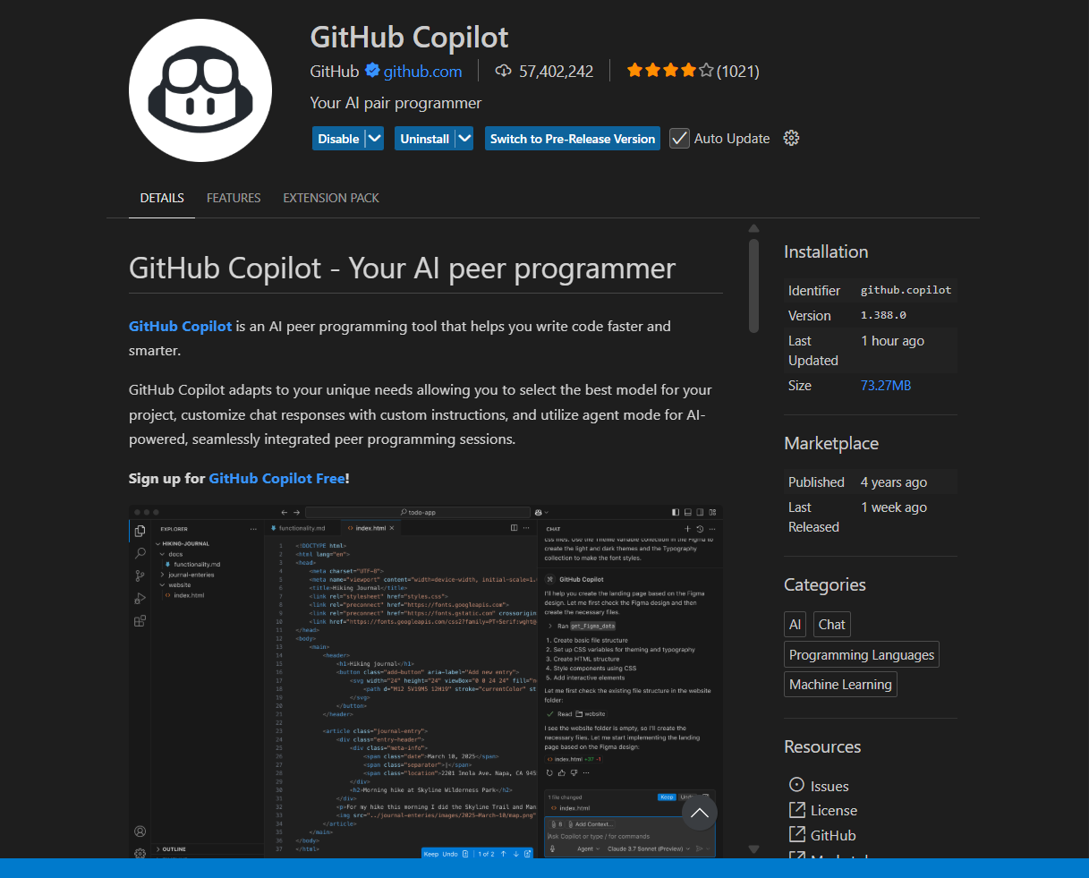

**Task Description#2**

Use Copilot to generate a is_prime() Python function

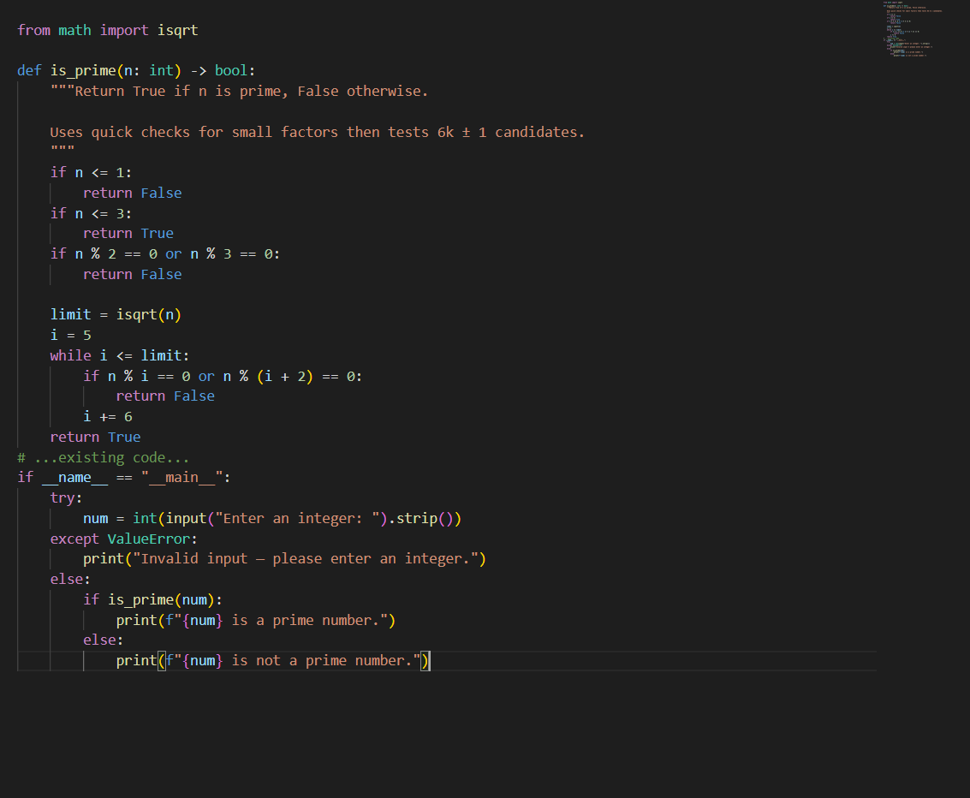

**Output:**

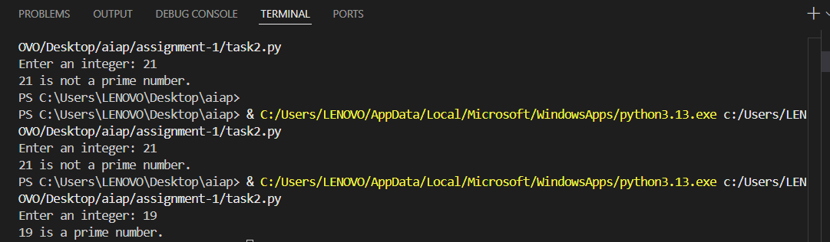

**Task Description#3**

Write a comment like # Function to reverse a string and use Copilot to generate the function.

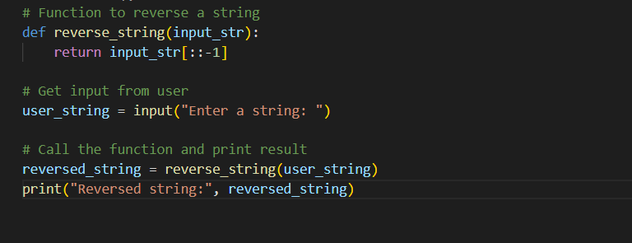

**OUTPUT:**

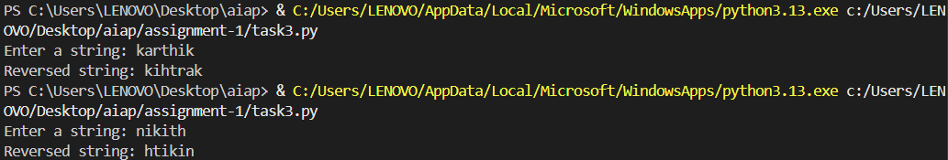

**Task Description#4**

Generate both recursive and iterative versions of a factorial function using comments..

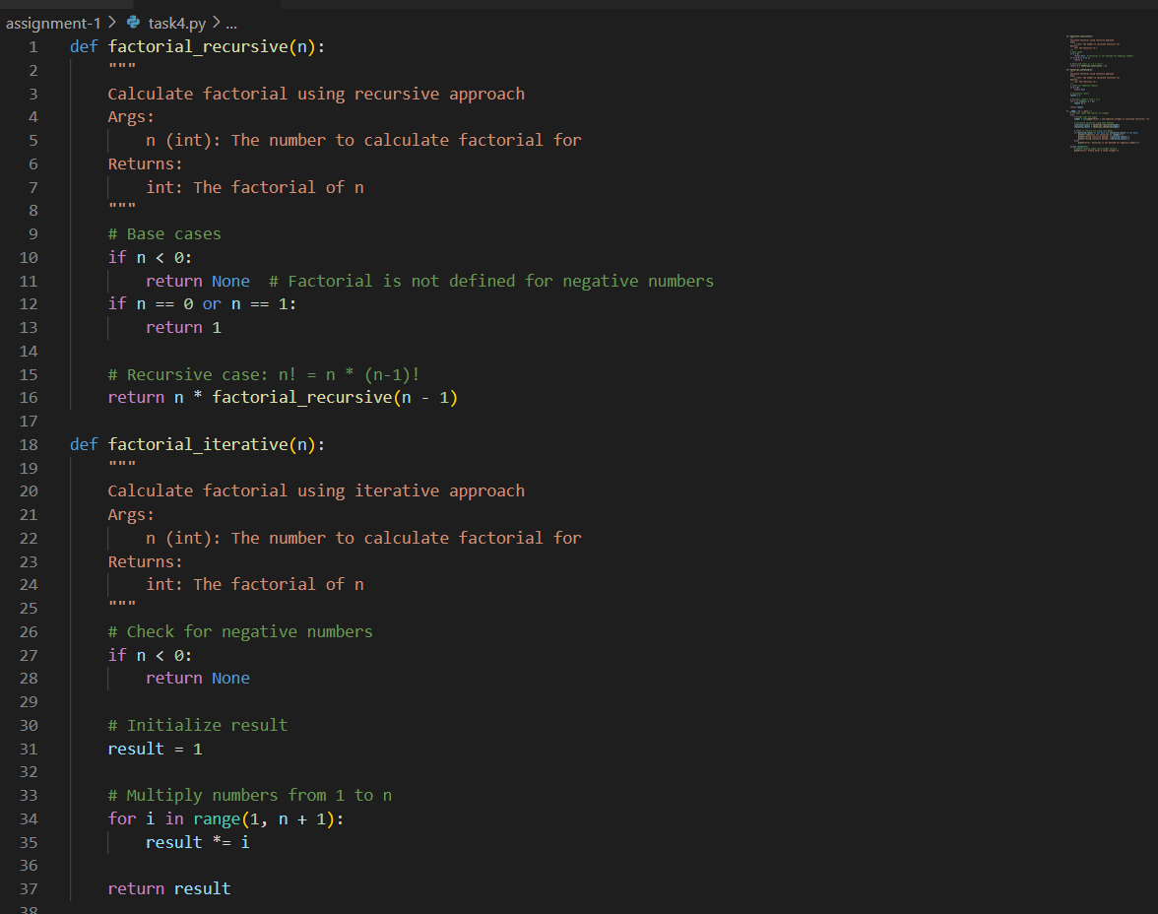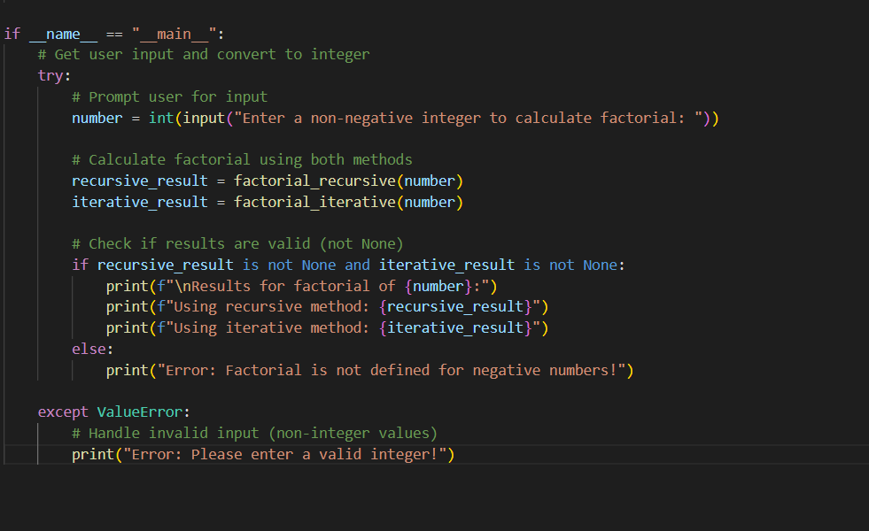

**OUTPUT:  
  
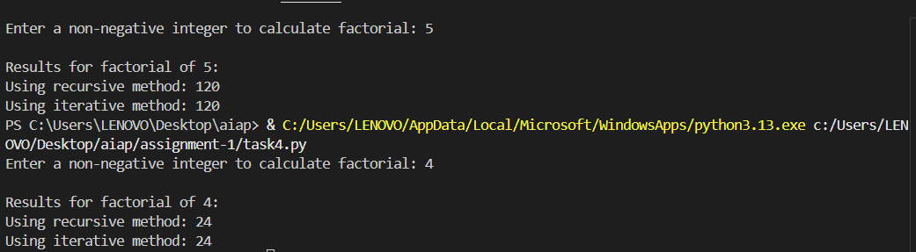**

**Task Description#5**

Use Copilot to find the largest number in a list. Assess code quality and efficiency

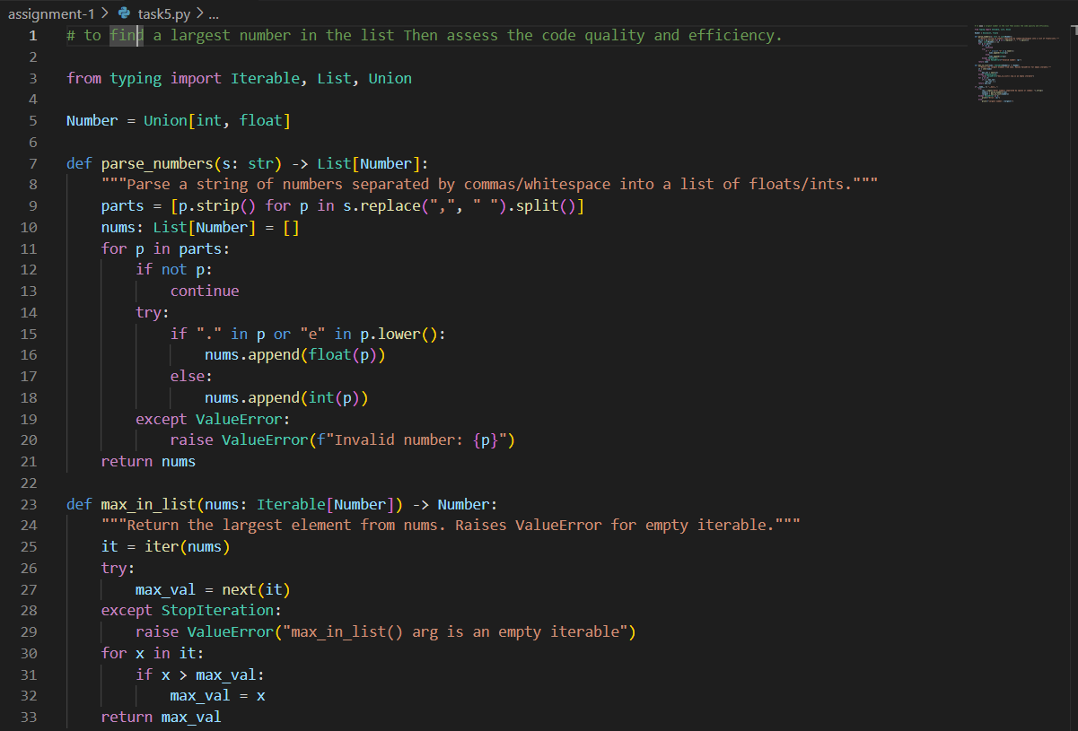

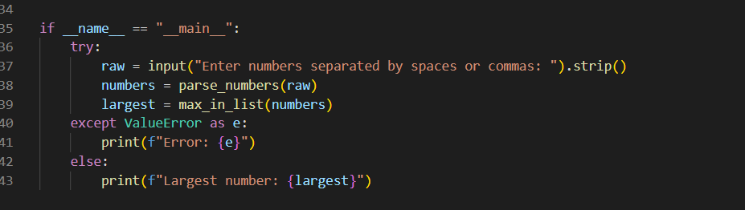

**OUTPUT:**

